**BRAIN TUMOUR DETECTION AND CLASSIFICATION BASED ON THEIR POSITIONWITHINTHE BRAIN USING CONVOLUTIONAL NEURAL NETWORK**

**NDEDA SOLOMON ONYANGO CO25-O1-1940/2020**

**Project documentation submitted to the Department of Information Technology in the school of computer science and Information Technology in partial fulfillment of the requirements for the award of the degree of BSc. in Business Information Technology at Dedan Kimathi University of Technology**

**JANUARY 2024**

## 

## **DECLARATION**

**STUDENT:**

This project is my original work and has not been presented for a degree in any other University.

NDEDA SOLOMON ONYANGO CO25-01-1940/2020

………………….. ……………………..

SIGNATURE DATE

**SUPERVISOR:**

This project has been submitted for examination with my approval as the university supervisor.

NAME: SIGNATURE DATE

DR. JANE KURIA …………………… ………………………….

# **ABSTRACT**

A Brain tumor is considered as one of the aggressive diseases, among children and adults. Brain tumors account for 85 to 90 percent of all primary Central Nervous System (CNS) tumors. Every year, around 11,700 people are diagnosed with a brain tumor. The 5-year survival rate for people with a cancerous brain or CNS tumor is approximately 34 percent for men and36 percent for women. Brain Tumors are classified as: Benign Tumor, Malignant Tumor, Pituitary Tumor, etc. Proper treatment, planning, and accurate diagnostics should be implemented to improve the life expectancy of the patients. The best technique to detect brain tumors is Magnetic Resonance Imaging (MRI)(Bhagat et al., 2022). A huge amount of image data is generated through the scans. These images are examined by the radiologist. A manual examination can be error-prone due to the level of complexities involved in brain tumors and their properties(Teoh, 2023)

Application of automated classification techniques using Machine Learning (ML) and Artificial Intelligence (AI)has consistently shown higher accuracy than manual classification. Hence, proposing a system performing detection and classification by using Deep Learning Algorithms using Convolution Neural Network (CNN), Artificial Neural Network (ANN), and Transfer Learning (TL) would be helpful to doctors all around the world(Joshi et al., 2022).

**TABLE OF CONTENTS**

**DECLARATION** i

**ABSTRACT** ii

**CHAPTER ONE: INTRODUCTION** 1

**1.1** **Background** 1

**1.2** **Statement of the problem** 4

**1.3** **Objectives** 5

**1.3.1** **General Objective** 5

**1.3.2** **Specific objectives** 5

**1.4** **Research Questions** 5

**1.5** **Justification** 6

**1.6** **Scope** 6

**CHAPTER TWO: LITERATURE REVIEW** 7

**2.1** **Introduction** 7

**2.2** **Case studies** 7

2.2.1 **Case study 1: Automated Brain Tumor Type Classification Using Magnetic Resonance Imaging Texture** 7

**2.2.2** **Case study 2: A Comparative Study on Brain Tumor Detection and Classification Using Neural Network** 7

**2.2.3** **Case Study 3: Deep Convolutional Neural Networks for Multi-Class Brain Disease Classification Using MRI Images** 8

**2.2.4** **Case study 4: Multi-Class Brain Tumor Classification Using Deep Learning Convolutional Neural Network** 8

**2.3** **Summary** 9

**2.4** **Research Gap** 10

**2.5** **Proposed methodology.** 10

**CHAPTER THREE: METHODOLOGY** 11

**3.1** **Introduction** 11

**3.2** **Fact Finding Techniques** 11

**3.3** **Software Design - Software Development Procedures** 11

**3.3.1** **System Architecture** 11

**3.3.2** **CNN Model Development** 12

**3.3.3** **VGG16 Architecture** 12

**3.3.4** **Integration and Testing** 14

**3.4** **Preliminary Data Processing and Analysis** 14

**3.4.1** **Data Collection and Preprocessing** 14

**3.4.2** **Training and Validation** 16

**3.4.3** **3.4.3 Performance Evaluation** 17

REFERENCES 18

**APPENDICES** 21

**Appendix A: Resources** 21

**Appendix B: Gannt chart** 22

**Appendix C: Budget** 22

**List of Figures**

Figure 1:system development 11

Figure 2:cnn architecture 12

Figure 3:Glioma tumors 15

Figure 4:meningioma tumors 15

Figure 5:Pituitary tumors 16

Figure 6:No tumors 16

Figure 7:project schedule 22

**List of Tables**

Table 1:Hardware Requirements 21

Table 2:software Requirements 21

Table 3:budget 22

# **CHAPTER ONE: INTRODUCTION**

## **Background**

The human brain is susceptible to various types of tumors, differing in origin, characteristics, and potential impact on health. Gliomas arise from glial cells, meningiomas from the meninges, and pituitary tumors from the pituitary gland. Each type demands specific attention due to its unique features and potential consequences(Uysal, 2023).

The clinical implications of brain tumors are diverse. Some tumors may be aggressive, requiring immediate and targeted intervention, while others might be benign but impactful due to their location. The severity of the condition and its effects on surrounding tissues contribute to the complexity of the diagnostic process(Smith‐Cohn et al., 2022).

The understanding and genesis of brain tumor detection and classification represent a critical domain within medical diagnostics, driven by the complexities of identifying and categorizing tumors in the intricate landscape of the brain. This multifaceted problem arises from the need to discern between different types of tumors, such as gliomas, meningiomas, pituitary tumors, and non-tumor cases, each presenting its own set of challenges. Not all abnormalities detected in brain imaging are tumors. Vascular malformations, cysts, and other non-tumorous conditions can mimic the appearance of tumors, necessitating a comprehensive understanding of the differential diagnoses to avoid unnecessary treatments and interventions(Smith‐Cohn et al., 2022),(Liang, 2022)

Accurate detection and classification of brain tumors are fundamental for devising effective treatment plans. The location, size, and type of tumor significantly influence decisions regarding surgery, radiation therapy, or other targeted treatments. Misclassification or oversight can lead to suboptimal patient care(Lakshmi Veeranki et al., 2023).

The genesis of the problem is intricately linked with the advancements in medical imaging technologies, particularly Magnetic Resonance Imaging (MRI). While these technologies provide unprecedented insights into the brain's structure, they also generate vast amounts of complex data that require advanced analytical tools for interpretation(Liang, 2022).

The rise in the complexity of imaging data, coupled with the need for nuanced interpretations, has outpaced traditional manual diagnostic approaches. The intricate nature of brain structures and the subtle differences between tumor types make it challenging for human diagnosticians to consistently achieve accurate and timely classifications(Liang, 2022).

The genesis of a potential solution lies in the integration of Machine Learning (ML) and Artificial Intelligence (AI). Recognizing the limitations of manual diagnostics, researchers have turned to computational approaches, such as Convolutional Neural Networks (CNNs), Artificial Neural Networks (ANNs), and Transfer Learning (TL), to automate and enhance the accuracy of brain tumor detection and classification(Bhagat et al., 2022).

The problem's genesis is further rooted in the clinical imperatives of timely and precise diagnostics. Brain tumors have profound implications for patient outcomes, and the global impact of developing effective automated systems is evident in the quest to improve healthcare accessibility and outcomes worldwide(Bala et al., 2022).

In essence, the understanding and genesis of brain tumor detection and classification underscore the challenges posed by the intricate nature of the brain and the imperative to leverage advanced technologies for more accurate and efficient diagnostic processes. The ongoing exploration of solutions, particularly in the realm of AI and ML, represents a promising avenue for addressing this complex healthcare challenge.

Brain tumors can be perceived into global and local:

1. **Global Perspective**

The global challenge of brain tumor detection and classification transcends borders, impacting individuals across continents and prompting concerted efforts to enhance diagnostic capabilities and treatment strategies. Brain tumors, including gliomas, meningiomas, and pituitary tumors, contribute significantly to the worldwide disease burden, with the World Health Organization (WHO) estimating substantial new cases annually(Sanai, 2014). The adoption of advanced medical imaging technologies, particularly Magnetic Resonance Imaging (MRI), is a shared trend in developed and developing countries alike(Hilabi et al., 2023). This convergence fosters early detection and precise characterization of brain tumors, influencing diagnostic standards globally. The collaborative spirit within the global healthcare community, evident in international conferences, research consortia, and collaborative projects, enhances our understanding of the complexities associated with brain tumor detection and classification. However, challenges persist in addressing disparities in access to advanced treatments, with varying resources for surgical interventions and radiation therapy, highlighting the need for equitable healthcare outcomes for individuals diagnosed with brain tumors on a global scale(Hilabi et al., 2023).

1. **Local Perspective**

At the local level, brain tumor detection is shaped by unique healthcare infrastructures, cultural influences, and policy dynamics, presenting region-specific challenges and opportunities. Disparities in access to advanced treatments, a hallmark of the local scenario, are influenced by variations in healthcare infrastructure. Local epidemiological impacts, including varying incidence rates and cultural perceptions of healthcare, contribute to the distinct landscape of brain tumor diagnosis. The adoption of advanced medical imaging technologies may vary, affecting the speed and accuracy of diagnostics(Guo et al., 2023). Skilled healthcare professionals, cultural beliefs, and socioeconomic factors further influence the local understanding and management of brain tumors. While public health initiatives and regional policies play a crucial role, addressing these factors in a localized manner is essential for effective diagnosis and treatment. Bridging gaps in expertise, technology access, and public awareness is imperative to tailor solutions to the unique challenges presented by brain tumor detection at the local level(Tebha et al., 2023).

Brain tumor detection and classification based on their location is a crucial aspect of medical diagnostics, aiming to enhance treatment planning and improve patient outcomes. Gliomas, meningiomas, no-tumor cases, and pituitary tumors represent distinct categories, each with its unique characteristics and challenges(Guo et al., 2023).

1. **Gliomas**

Gliomas are a type of tumor that originates from glial cells, which provide support and protection for neurons in the central nervous system. These tumors can vary widely in terms of aggressiveness, with glioblastoma multiforme being one of the most malignant forms. Accurate detection and classification of gliomas are essential for determining the appropriate treatment strategy, as the severity and location of these tumors greatly influence prognosis(Wu et al., 2023).

1. **Meningiomas**

Meningiomas develop from the meninges, the protective layers surrounding the brain and spinal cord. Although often considered benign, meningiomas can cause significant health issues depending on their size and location. Detecting and classifying meningiomas help guide treatment decisions, including whether surgical intervention is necessary(Rodríguez-Hernández et al., 2022).

1. **No-tumor Cases.**

Not all anomalies detected in brain imaging are tumors; some abnormalities may result from vascular malformations, cysts, or other non-tumorous conditions. Properly identifying cases with no tumors is crucial for avoiding unnecessary treatments and interventions, ensuring that patients receive appropriate care based on their specific conditions(Wang et al., 2022).

1. **Pituitary tumor**

Pituitary tumors originate in the pituitary gland, a small but vital gland located at the base of the brain. These tumors can affect hormonal balance and lead to various health issues(Paz-Pacheco, 2023). Detecting and classifying pituitary tumors are essential for planning targeted treatments, including surgery or hormonal therapies, to manage the impact on the endocrine system(Albano et al., 2023).

Advancements in medical imaging technology, particularly Magnetic Resonance Imaging (MRI), have played a pivotal role in the accurate detection and classification of brain tumors. Furthermore, the integration of Machine Learning (ML) and Artificial Intelligence (AI) techniques, such as Convolutional Neural Networks (CNNs) and Artificial Neural Networks (ANNs), has shown promise in automating the classification process(Iglesias, 2023). These technologies enable efficient analysis of large datasets, improving the accuracy and speed of diagnosis. Additionally, the application of Transfer Learning (TL) further enhances the performance of these models, making them valuable tools for healthcare professionals worldwide in the quest for early and precise brain tumor detection and classification(Rasheed et al., 2023).

## **Statement of the problem**

The increasing prevalence of brain tumors, with an estimated 787,000 cases in the United States by 2020, signifies a substantial healthcare challenge(Neff et al., 2023). Despite being the 10th leading cause of death globally, brain tumors remain less common than other malignancies(Neff et al., 2023). However, their long-term impact and complex nature pose significant hurdles, exacerbated by challenges in understanding abnormalities in size and location. Moreover, the reliance on professional neurosurgeons for MRI analysis creates a bottleneck, especially in developing countries where a shortage of skilled doctors and limited tumor knowledge hinder timely and accurate reporting(Tebha et al., 2023). The need for a comprehensive and efficient solution is evident, and the development of an automated cloud-based system emerges as a promising avenue to alleviate these challenges, providing timely and accessible insights into brain tumor diagnostics.

## **Objectives**

### **General Objective**

To develop a model for detecting and classifying brain tumors based on their position within the brain

### **Specific objectives**

1. To train the CNN Model
2. To evaluate the model’s performance
3. To investigate data preprocessing techniques
4. To conduct a systematic review of existing models

## **Research Questions**

Can the training process of the Convolutional Neural Network (CNN) model, utilizing a diverse dataset inclusive of gliomas, pituitary tumors, no-tumor cases, and meningiomas, significantly enhance its proficiency in accurately detecting and classifying brain tumors based on their specific positions within the brain?

Can the developed Convolutional Neural Network (CNN) model demonstrate superior performance in terms of accuracy, precision, recall, and F1-score, especially in the precise localization of brain tumors within the brain? How does this performance compare to established benchmarks and traditional diagnostic methods?

Can different data preprocessing techniques effectively contribute to enhancing the quality and reliability of the dataset used to train and evaluate the CNN model for detecting and classifying brain tumors? In what ways can these techniques address variations in imaging data and improve the model's generalization across diverse brain tumor positions?

Can a systematic review of existing models in the field of brain tumor detection and classification provide insights into their strengths, weaknesses, and gaps? Can the synthesis of findings from the literature inform the enhancement of the Convolutional Neural Network (CNN) model to achieve improved accuracy and effectiveness in detecting and classifying brain tumors based on their specific positions within the brain?

## **Justification**

The research is motivated by the pressing need to address challenges inherent in the detection and classification of brain tumors. The intricate nature of brain structures, coupled with the diverse characteristics of tumors, emphasizes the necessity for advanced models such as the proposed Convolutional Neural Network (CNN). Through systematic review, the study seeks to comprehensively understand the existing landscape of brain tumor detection models, aiming to identify gaps and areas for enhancement that will inform the development of an advanced, automated solution.

This research is poised to deliver significant benefits across multiple dimensions. Clinically, the enhanced CNN model promises improved accuracy in detecting and classifying brain tumors, thereby influencing treatment planning and patient outcomes. The streamlined diagnostic process, facilitated by the proposed automated cloud-based system, contributes to healthcare efficiency, particularly in regions where access to skilled neurosurgeons is limited. Moreover, the global accessibility of the solution has the potential to bridge healthcare disparities. Beyond immediate application, the systematic review enriches scientific knowledge in the field, laying a foundation for future research. Overall, the research stands to advance technological innovation in healthcare, positively impacting both current clinical practices and the trajectory of future developments in brain tumor diagnostics.

## **Scope**

This study focuses on the development of a deep learning Convolutional Neural Network (CNN) for the early detection of brain tumors, primarily using magnetic resonance imaging (MRI) scans. Geographically, the research draws on diverse datasets but aims for a universally applicable model, adaptable to varying imaging techniques. The target population encompasses individuals of all ages undergoing brain imaging, emphasizing inclusivity across demographics and ethnicities. The primary goal is the seamless integration of the CNN model into routine clinical practice, ensuring user-friendly adoption by healthcare professionals. Ethical considerations, including patient privacy and compliance with institutional guidelines, are prioritized. While recognizing potential limitations in imaging quality and dataset diversity, the study aims to contribute to improved patient outcomes globally by facilitating early tumor detection and intervention.

# **CHAPTER TWO: LITERATURE REVIEW**



## **Introduction**

This chapter reviewed literature on information systems, which was published in textbooks, journals, the internet and others, and is relevant to the problem under study. And it also involved a review of previous studies in relation to the research topic of analyzing, developing and implementing a Brain tumor detection system.

## **Case studies**

### **Case study 1: Automated Brain Tumor Type Classification Using Magnetic Resonance Imaging Texture**

This study employs a methodology involving the extraction of texture features from magnetic resonance imaging (MRI) for automated brain tumor type classification. Convolutional neural networks (CNNs) are likely utilized for the extraction of intricate patterns and textures indicative of different tumor types(Jaware et al., 2022).

Despite its contributions, the study might exhibit limitations, such as potential biases in the dataset used for training and validation. The generalizability of the proposed model to diverse populations or imaging protocols could be a potential gap(Jaware et al., 2022).

To address potential gaps, integrating diverse datasets representing various populations and imaging conditions is hypothesized to enhance model generalizability. Furthermore, the study might benefit from implementing transfer learning techniques, leveraging pre-trained models on larger datasets. (Hypothesized Techniques: Integrating Diverse Datasets, Transfer Learning)

### **Case study 2: A Comparative Study on Brain Tumor Detection and Classification Using Neural Network**

This comparative study likely involves the application of various neural network models for brain tumor detection and classification. CNNs may be utilized for their ability to automatically learn hierarchical features from MRI images(Felipe et al., 2023).

Possible gaps may include limited exploration of the interpretability of the CNN-based models and potential challenges in handling variations in imaging resolutions or acquisition parameters(Felipe et al., 2023).

Addressing potential gaps could involve exploring advanced techniques for model interpretability, such as attention mechanisms. Additionally, investigating the impact of varying imaging conditions and implementing advanced data augmentation techniques may improve model robustness. (Hypothesized Techniques: Model Interpretability, Advanced Data Augmentation)

### **Case Study 3: Deep Convolutional Neural Networks for Multi-Class Brain Disease Classification Using MRI Images**

This study likely adopts deep convolutional neural networks for multi-class brain disease classification, focusing on the discrimination of different tumor types using MRI images(Jayachandran et al., 2023)

Potential gaps might include limited exploration of the impact of varying imaging protocols or resolutions on model performance and the need for detailed model interpretability analyses(Jayachandran et al., 2023).

Addressing potential gaps could involve exploring the integration of diverse datasets with varying imaging conditions, as well as implementing techniques for improved model interpretability, such as saliency maps. (Hypothesized Techniques: Integrating Diverse Datasets, Model Interpretability)

### **Case study 4: Multi-Class Brain Tumor Classification Using Deep Learning Convolutional Neural Network**

This recent study likely employs deep learning convolutional neural networks for multi-class brain tumor classification, with a focus on distinguishing between different tumor types(Rastogi et al., 2021).

Possible gaps might include the need for detailed analyses regarding the impact of varying imaging protocols or resolutions on model performance and potential biases in the dataset used(Rastogi et al., 2021).

Addressing potential gaps could involve exploring advanced data augmentation techniques and conducting a thorough examination of the dataset for biases, as well as implementing transfer learning for improved model adaptability. (Hypothesized Techniques: Advanced Data Augmentation, Transfer Learning)

## **Summary**

The reviewed literature encompasses diverse studies focusing on brain tumor detection utilizing Convolutional Neural Networks (CNNs). Each study presents distinctive methodologies, gaps, and hypothesized techniques for improvement. However, common weaknesses emerge, providing insights into potential advancements in the field.

The study by (Jaware et al., 2022) emphasizes automated brain tumor type classification through MRI texture features. While commendable, the reliance on specific datasets raises concerns about model generalizability. Addressing this weakness involves integrating diverse datasets and considering transfer learning for enhanced adaptability.

(Felipe et al., 2023) undertakes a comparative approach to brain tumor detection with various neural network models. The identified gaps highlight the need for improved model interpretability and robustness against varying imaging conditions. Techniques such as attention mechanisms and advanced data augmentation could address these weaknesses.

(Jayachandran et al., 2023)'s research focuses on multi-class brain disease classification, emphasizing discrimination between tumor types. Gaps include limited exploration of the impact of imaging variations and the need for detailed model interpretability analyses. Hypothesized techniques involve integrating diverse datasets and incorporating interpretability techniques like saliency maps.

Islam et al.'s recent study (2021) delves into multi-class brain tumor classification using deep CNNs. Identified weaknesses include insufficient analyses of dataset biases and limited consideration of varying imaging conditions. Addressing these issues involves advanced data augmentation, thorough dataset examination for biases, and the implementation of transfer learning for improved model adaptability.

In summary, while these studies contribute significantly to the understanding of brain tumor detection with CNNs, there is a collective need for enhanced generalizability, model interpretability, and robustness against varying imaging conditions. Future research should prioritize addressing these weaknesses to ensure the reliability and applicability of CNN-based models in clinical settings.

## **Research Gap**

The literature review reveals a notable research gap in the exploration of the impact of varying imaging conditions and protocols on the performance of Convolutional Neural Networks (CNNs) for brain tumor detection. While several studies acknowledge the importance of diverse datasets and generalizability, there is a limited focus on systematically assessing how changes in imaging resolutions, acquisition parameters, and potential biases in datasets influence the reliability of the CNN models. The existing literature primarily centers on the architectural aspects of CNNs and the discriminative capabilities in classifying tumor types. Therefore, the unexplored terrain lies in the comprehensive investigation of how these models respond to different imaging scenarios, which is crucial for ensuring their robustness and applicability in real-world clinical settings. Addressing this research gap could significantly contribute to the refinement and optimization of CNN-based brain tumor detection models, fostering greater reliability and generalizability across varied imaging conditions.

## **Proposed methodology.**

To address the identified research gap in the impact of varying imaging conditions on CNN-based brain tumor detection, I propose a comprehensive methodology that integrates two key components: (1) the augmentation of existing datasets to simulate diverse imaging scenarios and (2) the incorporation of attention mechanisms within the CNN architecture to enhance interpretability. The augmented datasets will encompass variations in imaging resolutions, acquisition parameters, and potential biases, providing a robust training ground for the CNN models. Additionally, attention mechanisms will be integrated to highlight regions within the MRI images that significantly influence the model's decision-making process. This approach aims to enhance the model's adaptability to different imaging conditions and provide insights into the key features influencing its classifications, ultimately contributing to the development of more robust and interpretable CNN models for brain tumor detection in clinical settings.

# **CHAPTER THREE: METHODOLOGY**



## **Introduction**

Brain tumors are a serious health concern, and their early detection plays a crucial role in effective treatment. This research focuses on the development of a rain tumor detection system using Convolutional Neural Networks (CNNs). CNNs have shown remarkable success in image recognition tasks, making them suitable for medical image analysis. This section provides an overview of the research objectives, significance, and the proposed methodology for brain tumor detection.

## **Fact Finding Techniques**

To gather relevant information and insights into brain tumor detection, fact-finding techniques will be employed. This includes a comprehensive literature review of existing methodologies, recent advancements in CNN-based medical image analysis, and insights from domain experts. Interviews with healthcare professionals and radiologists will be conducted to understand the challenges and requirements for an effective brain tumor detection system.

## **Software Design - Software Development Procedures**

### **System Architecture**

The proposed system will be designed with a modular architecture to facilitate scalability and maintainability. The core of the system will be a CNN model optimized for brain tumor detection.

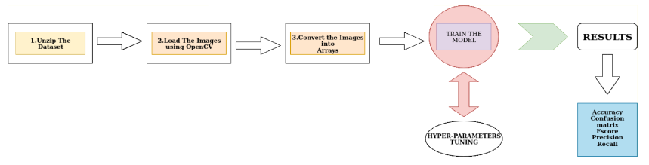

Figure 1:system development

Figure 1. The above picture presents at nutshell how the model will be developed starting with unzipping the obtained dataset, loading the images using the OpenCV library, converting the images to numpy array before training the CNN model after which Model tuning will be performed and finally measuring calculating and evaluating metrics

### **CNN Model Development**

A Convolutional Neural Network (CNN) will be designed and trained using a dataset of labeled brain images. The architecture will consist of multiple convolutional layers for feature extraction and pooling layers for dimensionality reduction. The model will be fine-tuned to optimize its performance for detecting different types and sizes of brain tumors.

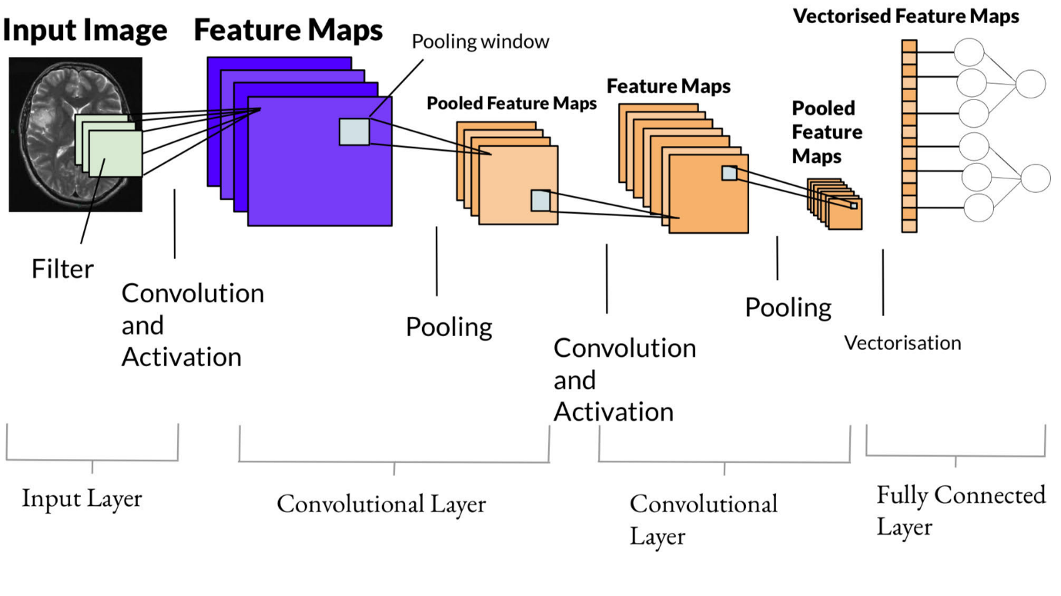

Figure 2:cnn architecture.

### **VGG16 Architecture**

VGG16, as its name suggests, is a 16-layer deep neural network. VGG16 is thus a relatively extensive network with a total of 138 million parameters—it’s huge even by today’s standards. However, the simplicity of the VGGNet16 architecture is its main attraction.

The VGGNet architecture incorporates the most important convolution neural network features.

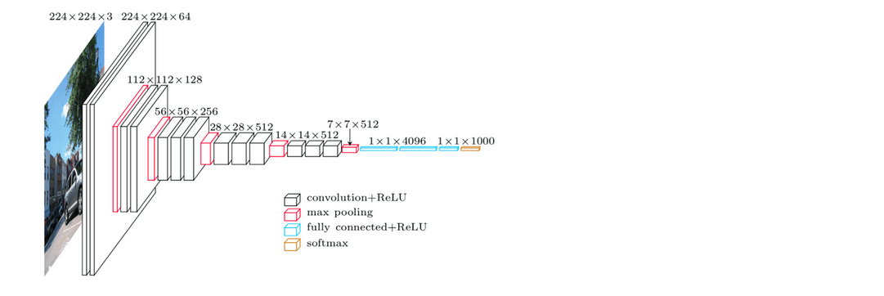

A VGG network consists of small convolution filters. VGG16 has three fully connected layers and 13 convolutional layers.

Here is a quick outline of the VGG architecture:

1. **Input—**VGGNet receives a 224×224 image input. In the ImageNet competition, the model’s creators kept the image input size constant by cropping a 224×224 section from the center of each image.
2. **Convolutional layers—**the convolutional filters of VGG use the smallest possible receptive field of 3×3. VGG also uses a 1×1 convolution filter as the input’s linear transformation.
3. **ReLu activation**—next is the Rectified Linear Unit Activation Function (ReLU) component, AlexNet’s major innovation for reducing training time. ReLU is a linear function that provides a matching output for positive inputs and outputs zero for negative inputs. VGG has a set convolution stride of 1 pixel to preserve the spatial resolution after convolution (the stride value reflects how many pixels the filter “moves” to cover the entire space of the image).
4. **Hidden layers—**all the VGG network’s hidden layers use ReLU instead of Local Response Normalization like AlexNet. The latter increases training time and memory consumption with little improvement to overall accuracy.
5. **Pooling layers–**A pooling layer follows several convolutional layers—this helps reduce the dimensionality and the number of parameters of the feature maps created by each convolution step. Pooling is crucial given the rapid growth of the number of available filters from 64 to 128, 256, and eventually 512 in the final layers.
6. **Fully connected layers—**VGGNet includes three fully connected layers. The first two layers each have 4096 channels, and the third layer has 1000 channels, one for every class.

### **Integration and Testing**

Once the CNN model is developed, it will be integrated into the overall system. Rigorous testing will be conducted to ensure the model's accuracy, robustness, and efficiency. This involves validation on various datasets, including both synthetic and real-world medical images.

## **Preliminary Data Processing and Analysis**

### **Data Collection and Preprocessing**

The dataset for training and testing the CNN model is obtained from Kaggle.com.The name of the dataset is “Brain tumor classification: <https://ww.kaggle.com/dataset/sartajbhuvaji/brain-tumor-classification-mri>.

Below are sample categories of the images from the dataset.

1. **Glioma tumor**

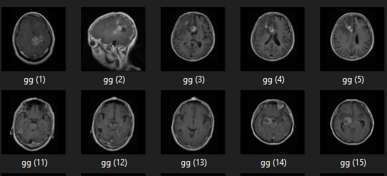

Figure 3:Glioma tumors

1. **Meningioma tumor**

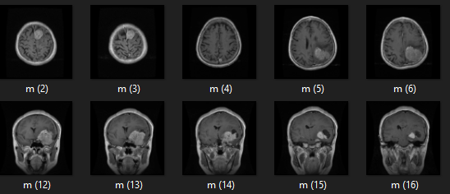

Figure 4:meningioma tumors

1. **Pituitary tumor**

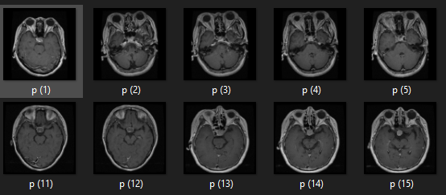

Figure 5:Pituitary tumors

1. **No tumor**

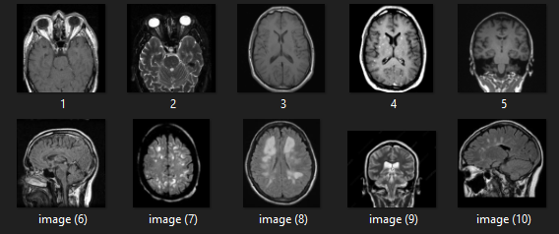

Figure 6:No tumors

Preprocessing steps, including normalization, resizing, and augmentation, will be applied to enhance the model's generalization ability.

### **Training and Validation**

The CNN model will be trained on the preprocessed dataset, and its performance will be evaluated using validation data. Hyperparameter tuning and optimization techniques will be employed to enhance the model's accuracy and minimize overfitting.

### **3.4.3 Performance Evaluation**

The trained model will be evaluated on a separate test dataset, measuring key performance metrics such as sensitivity, specificity, and overall accuracy. Comparative analysis with existing methodologies will be conducted to demonstrate the effectiveness of the proposed CNN-based brain tumor detection system.

# REFERENCES

Albano, L., Losa, M., Barzaghi, L. R., & Mortini, P. (2023). *Benign and Malignant Tumors of the Pituitary Gland* (pp. 281–297). doi: 10.1007/978-3-031-23705-8_10

Bala, D., Islam, M. A., Hossain, M. I., Mynuddin, M., Hossain, M. A., & Hossain, Md. S. (2022). Automated Brain Tumor Classification System using Convolutional Neural Networks from MRI Images. *2022 International Conference on Engineering and Emerging Technologies (ICEET)*, 1–6. doi: 10.1109/ICEET56468.2022.10007116

Bhagat, A. K., & Vekariya, D. (2022). Computational Intelligence approach to improve the Classification accuracy of Brain Tumor Detection. *2022 5th International Conference on Contemporary Computing and Informatics (IC3I)*, 659–664. doi: 10.1109/IC3I56241.2022.10073470

Felipe, C. dos S., Alva, T. A. P., Winck, A. T., & Becker, C. D. L. (2023). An Approach in Brain Tumor Classification: The Development of a New Convolutional Neural Network Model. *Anais Do XX Encontro Nacional de Inteligência Artificial e Computacional (ENIAC 2023)*, 28–42. doi: 10.5753/eniac.2023.233530

Guo, J., Dickson, S., Berenbrok, L. A., Tang, S., Essien, U. R., & Hernandez, I. (2023). Racial disparities in access to health care infrastructure across US counties: A geographic information systems analysis. *Frontiers in Public Health*, *11*. doi: 10.3389/fpubh.2023.897007

Hilabi, B. S., Alghamdi, S. A., & Almanaa, M. (2023). Impact of Magnetic Resonance Imaging on Healthcare in Low- and Middle-Income Countries. *Cureus*. doi: 10.7759/cureus.37698

Iglesias, P. (2023). Aggressive and Metastatic Pituitary Neuroendocrine Tumors: Therapeutic Management and Off-Label Drug Use. *Journal of Clinical Medicine*, *13*(1), 116. doi: 10.3390/jcm13010116

Jaware, T. H., Sarat Kumar, K., Badgujar, R. D., & Antonov, S. (Eds.). (2022). *Medical Imaging and Health Informatics*. Wiley. doi: 10.1002/9781119819165

Jayachandran, A., Sreema, M. A., Anandaraj, S. P., & Sudarson Rama Perumal, T. (2023). *Deep Convolutional Neural Network for Multi-class Brain Tumor Classification System in MRI Images* (pp. 561–572). doi: 10.1007/978-981-19-5845-8_39

Joshi, A., Rana, V., & Sharma, A. (2022). Brain Tumor Classification using Machine Learning and Deep Learning Algorithms: A Comparison. *Proceedings of the 2022 Fourteenth International Conference on Contemporary Computing*, 15–21. doi: 10.1145/3549206.3549210

Lakshmi Veeranki, P. S., Banavath, G. L., & Devi, P. R. (2023). Detection and Classification of Brain Tumors using Convolutional Neural Network. *2023 7th International Conference on Trends in Electronics and Informatics (ICOEI)*, 780–786. doi: 10.1109/ICOEI56765.2023.10125652

Liang, Y. (2022). Analysis of the Clinical Value of MRI Imaging in the Diagnosis of Brain Tumors. *2022 World Automation Congress (WAC)*, 113–117. doi: 10.23919/WAC55640.2022.9934124

Neff, C., Price, M., Cioffi, G., Kruchko, C., Waite, K. A., Barnholtz‐Sloan, J. S., & Ostrom, Q. T. (2023). Complete prevalence of primary malignant and nonmalignant brain tumors in comparison to other cancers in the United States. *Cancer*, *129*(16), 2514–2521. doi: 10.1002/cncr.34837

Paz-Pacheco, E. (2023). A Journal’s Hormonal Balance. *Journal of the ASEAN Federation of Endocrine Societies*, *38*(2), 5–5. doi: 10.15605/jafes.038.02.01

Rasheed, Z., Ma, Y.-K., Ullah, I., Al Shloul, T., Tufail, A. Bin, Ghadi, Y. Y., Khan, M. Z., & Mohamed, H. G. (2023). Automated Classification of Brain Tumors from Magnetic Resonance Imaging Using Deep Learning. *Brain Sciences*, *13*(4), 602. doi: 10.3390/brainsci13040602

Rastogi, S., Akbar, M., & Mittal, D. (2021). *Computer-Aided Diagnostic System for Classification and Segmentation of Brain Tumors Using Image Feature Processing, Deep Learning, and Convolutional Neural Network* (pp. 201–209). doi: 10.1007/978-981-33-4320-7_18

Rodríguez-Hernández, L. A., Uribe-Pacheco, R., Mondragon-Soto, M., Alvaro-Heredia, J., Reyes-Moreno, I., Montano-Tello, H., Gutierrez-Aceves, G. A., Guerrero-Juarez, V., Castro-Martinez, E., & Gonzalez-Aguilar, A. (2022). Assessing the Malignancy Risk of a Meningioma by Its Location. *Cureus*. doi: 10.7759/cureus.31213

# **APPENDICES**

## **Appendix A: Resources**

**Hardware requirements**

Table 1:Hardware Requirements

|  |  |  |
| --- | --- | --- |
| **Component requirement** | **Minimum requirement** | **Recommended** |
| **Processor (CPU)** | Quad-core CPU (e.g., Intel Core i5 or equivalent) | Multi-core CPU (e.g., Intel Core i7 or AMD Ryzen) |
| **Graphics Processing Unit (GPU)** | NVIDIA GeForce GTX 1060 or equivalent | |  |  | | --- | --- | |  | NVIDIA GeForce RTX 2080 or higher | |
| **Random Access Memory (RAM)** | 8GB DDR4 | 16GB DDR4 or higher |
| **Storage** | 250GB SSD or higher for model storage and datasets | 500GB SSD or higher for improved performance |

**Software Requirements**

Table 2:software Requirements

|  |  |
| --- | --- |
| component | Version/Environment |
| Operating System | Ubuntu 18.04 or later, windows 10 |
| Deep Learning Framework | TensorFlow and karas /Pytorch |
| CUDA Toolkit | CUDA 10.0 or later(for GPU acceleration) |
| cuDNN | cuDNN 7.6 or later (for GPU acceleration) |
| Python | Python 3.6 or later |
| Integrated Development Environment(ide) | Jupyter Notebook or VSCode |
| libraries | NumPy,OpenCV,Matplotlib.scikit-learn |

## **Appendix B: Gannt chart**



Figure 7:project schedule

## **Appendix C: Budget**

Table 3:budget

|  |  |
| --- | --- |
| **item** | **Estimated cost** |
| **Hardware** |  |
| High performance GPU(s) | Ksh. 100,000 |
| Storage (SSD/HDD) | Ksh. 5000 |
| **software** |  |
| Premium ide | Ksh. 3000 |
| Model development |  |
| Model training and validation | Ksh. 0 |
| **Evaluation and testing** |  |
| Performance metrics tools | Ksh. 5000 |
| Testing infrastructure | Ksh. 1000 |
| **Deployment and integration** |  |
| Deployment Tools and services | Ksh. 25000 |
| Integration with healthcare Systems | Ksh. 300000 |
| **miscellaneous** |  |
| Project management software | Ksh. 1000 |
| **Total estimated budget** | **Ksh. 440,000** |